Assignment -9.4
Name:G.Kalyan
HT.NO:2303a51853
Batch:13

Task 1: Auto-Generating Function Documentation in a Shared
Codebase
Scenario
You have joined a development team where several utility functions are
already implemented, but the code lacks proper documentation. New
team members are struggling to understand how these functions should
be used.
Task Description
You are given a Python script containing multiple functions without any
docstrings.
Using an AI-assisted coding tool:
• Ask the AI to automatically generate Google-style function
docstrings for each function
• Each docstring should include:
o A brief description of the function
o Parameters with data types
o Return values
o At least one example usage (if applicable)
Experiment with different prompting styles (zero-shot or context-based)
to observe quality differences.
Expected Outcome
• A Python script with well-structured Google-style docstrings
• Docstrings that clearly explain function behavior and usage
Improved readability and usability of the codebase
Output docstrings:
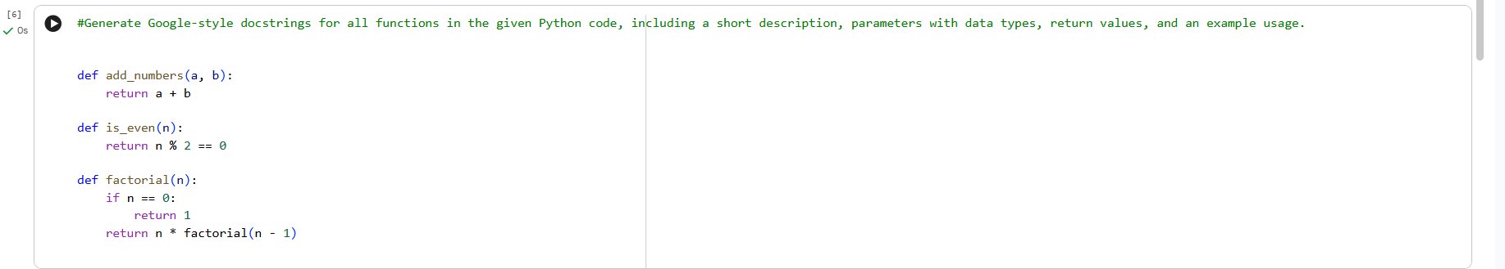

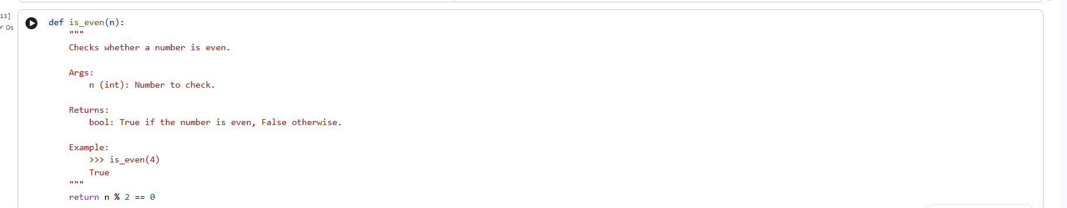
Justification:
The AI-generated Google-style docstrings clearly explain each function’s purpose, parameters, return values, and usage.
This improves code readability and helps new developers understand the functions quickly.
Type hints reduce ambiguity and prevent incorrect usage.
Overall, the documentation enhances maintainability and makes the codebase more professional.
Task 2:
Enhancing Readability Through AI-Generated Inline
Comments
Scenario
A Python program contains complex logic that works correctly but is
difficult to understand at first glance. Future maintainers may find it hard
to debug or extend this code.
Task Description
You are provided with a Python script containing:
• Loops
• Conditional logic
• Algorithms (such as Fibonacci sequence, sorting, or searching)
Use AI assistance to:
• Automatically insert inline comments only for complex or non-
obvious logic
• Avoid commenting on trivial or self-explanatory syntax
The goal is to improve clarity without cluttering the code.
Expected Outcome
• A Python script with concise, meaningful inline comments
• Comments that explain why the logic exists, not what Python
syntax does
• Noticeable improvement in code readability
Output docstrings:
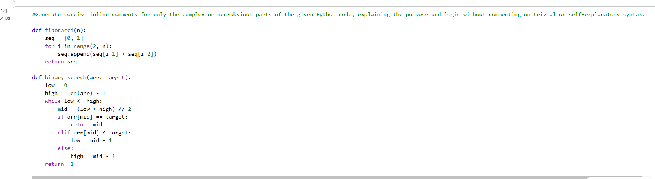
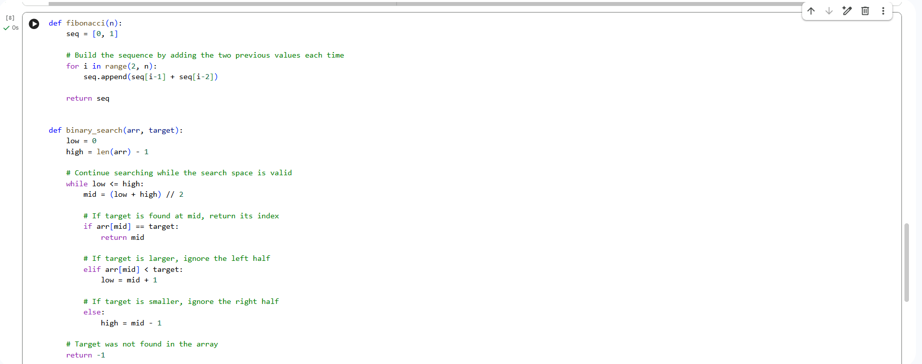
Justification:
The inline comments enhance readability by explaining the logic behind key algorithmic steps, such as updating Fibonacci values simultaneously and reducing the search space in binary search. They emphasize the purpose of the logic instead of basic Python syntax. This helps developers better understand, debug, and maintain the code. Overall, the script becomes clearer and more informative without unnecessary clutter.
Task 3: Generating Module-Level Documentation for a Python
Package
Scenario
Your team is preparing a Python module to be shared internally (or
uploaded to a repository). Anyone opening the file should immediately
understand its purpose and structure.
Task Description
Provide a complete Python module to an AI tool and instruct it to
automatically generate a module-level docstring at the top of the file
that includes:
• The purpose of the module
• Required libraries or dependencies
• A brief description of key functions and classes
• A short example of how the module can be used
Focus on clarity and professional tone.
Expected Outcome
• A well-written multi-line module-level docstring
• Clear overview of what the module does and how to use it
• Documentation suitable for real-world projects or repositories
Output docstrings:
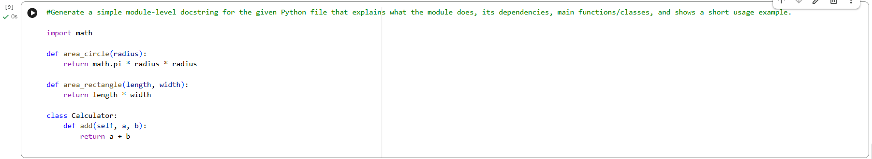
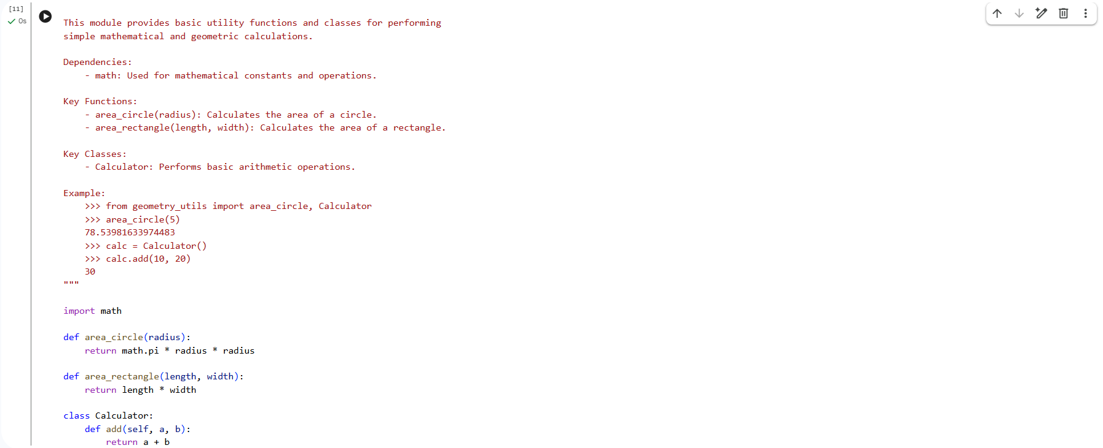
Justification:
Adding a module-level docstring gives a clear summary of the module’s purpose, dependencies, and overall structure, helping developers understand the code more quickly. It improves readability and promotes consistency across the project. Including a usage example demonstrates proper implementation and reduces confusion. Overall, it makes the codebase more professional and suitable for real-world applications.

Task 4: Converting Developer Comments into Structured Docstrings
Scenario
In a legacy project, developers have written long explanatory comments
inside functions instead of proper docstrings. The team now wants to
standardize documentation.
Task Description
You are given a Python script where functions contain detailed inline
comments explaining their logic.
Use AI to:
• Automatically convert these comments into structured Google-
style or NumPy-style docstrings
• Preserve the original meaning and intent of the comments
• Remove redundant inline comments after conversion
Expected Outcome
• Functions with clean, standardized docstrings
• Reduced clutter inside function bodies
• Improved consistency across the codebase
Output docstrings:

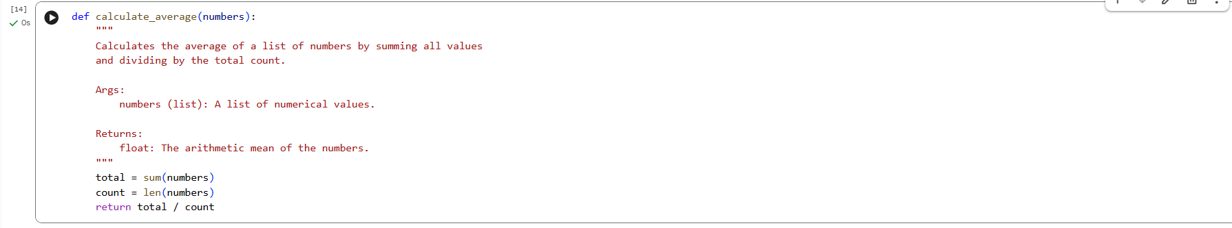
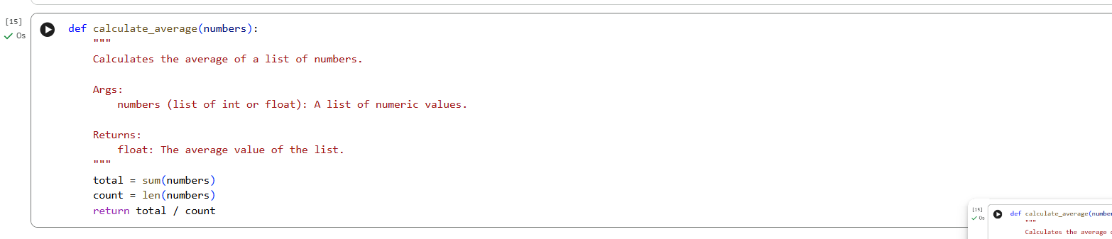
Justification:
Converting to Google-style docstrings greatly improves code readability and maintainability. These docstrings offer clear and structured descriptions of each function’s purpose, parameters (with types), return values, and practical examples. This helps developers quickly understand the code and use it correctly, reducing confusion and errors.
Task 5: Building a Mini Automatic Documentation Generator
Scenario
Your team wants a simple internal tool that helps developers start
documenting new Python files quickly, without writing documentation
from scratch.
Task Description
Design a small Python utility that:
• Reads a given .py file
• Automatically detects:
o Functions
o Classes
• Inserts placeholder Google-style docstrings for each detected
function or class
AI tools may be used to assist in generating or refining this utility.
Output docstrings:
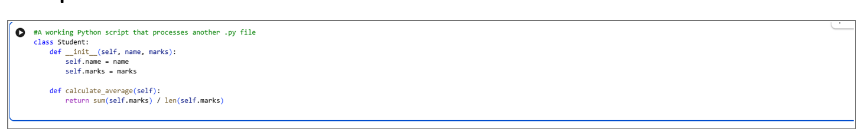

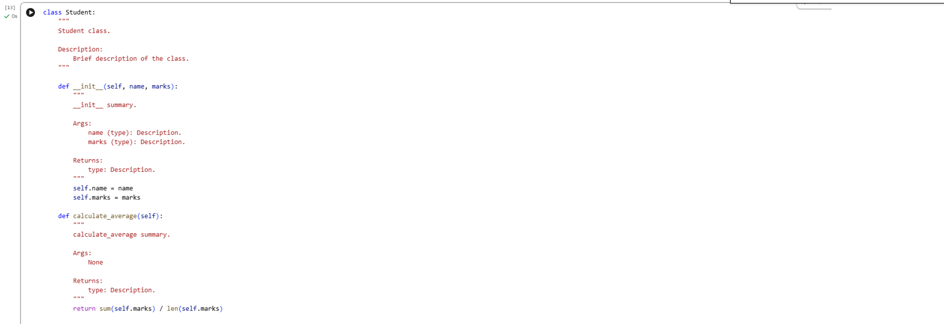
JUSTIFICATION:
The Mini Automatic Documentation Generator enables developers to quickly generate documentation for new Python files, reducing manual work and saving time. By automatically adding structured Google-style docstrings, it ensures consistency and improves code readability. The tool preserves existing logic and documentation, making it safe for use in real-world projects. Overall, it demonstrates how AI-assisted automation can improve documentation quality and long-term maintainability.

